Reading Data from a Text file
To read a file you must open it in "r" mode. In addition to that, you should also ensure that the file you want to read already exists because in "r" mode the open() function throws FileNotFoundError error if its unable to find a file.
To test whether a file exists or not, we can use isfile() function from the os.path module. The syntax of isfile() is:
isfile(path)
If file found at the given path isfile() returns True. Otherwise False. The following shell session demonstrates working of isfile() function.
1  2  3  4  5  6  7  8  9 | >>>  >>> import os  >>>  >>> os.path.isfile("/home/q/python101/Chapter-18/readme.md") # file exists  True  >>>  >>> os.path.isfile("/home/q/python101/Chapter-18/index.html") # file doesn't exists  False  >>>
The following programs demonstrates how to read a file using read(), readline() and readlines() function.
Example 1: Reading data at once using the read() method.
python101/Chapter-18/read_method_demo.py
1  2  3  4  5 | f = open("readme.md", "r")  print(f.read()) # read all content at once  f.close()
Output:
1  2  3 | First Line  Second Line  Third Line
Example 2: Reading data in chunks using the read() method.
python101/Chapter-18/reading_in_chunks.py
1  2  3  4  5  6  7 | f = open("readme.md", "r")  print("First chunk:", f.read(4), end="\n\n") # read the first 4 characters  print("Second chunk:", f.read(10), end="\n\n") # read the next 10 character  print("Third chunk:", f.read(), end="\n\n") # read the remaining characters  f.close()
Output:
1  2  3  4  5  6  7 | First chunk: Firs  Second chunk: t Line  Sec  Third chunk: ond Line  Third Line
When the file is open in read mode the file pointer points at the beginning of the file.
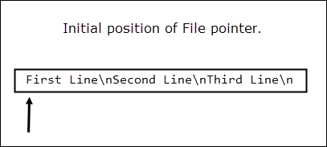
After reading first 4 characters, file pointer is at t.
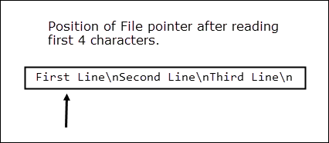
After reading the next 10 characters, file pointer is at character o.
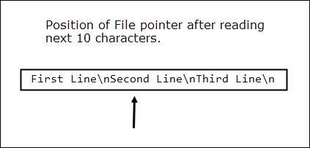
The third call to read() reads the remaining characters in the file and returns them as a string. At this point, the file position pointer points at the end of the file. Consequently, any subsequent calls to read() method returns an empty string.
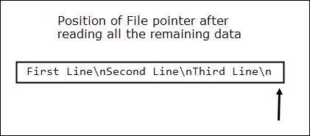
Example 3: Using readline() to read data from a file.
python101/Chapter-18/readline_method_demo.py
1  2  3  4  5  6  7  8  9  10  11  12  13  14  15  16  17  18 | f = open("readme.md", "r")  # read first line  print("Ist line:", f.readline())  # read the fist two characters in the second line  print("The first two characters in the 2nd line:", f.read(2), end="\n\n")  # read the remaining characters int the second line  print("Remaining characters in the 2nd line:", f.readline())  # read the next line  print("3rd line:", f.readline())  # end of the file reached, so readline returns an empty string ""  print("After end of file :", f.readline())  f.close()
Output:
1  2  3  4  5  6  7  8  9 | Ist line: First Line  The first two characters in the 2nd line: Se  Remaining characters in the 2nd line: cond Line  3rd line: Third Line  After end of file :
As usual when file is opened, the file pointer points at the beginning of the file.
The first call to readline() method moves the file pointer to the start of next line.
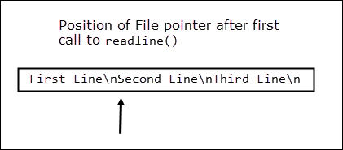
The read() function then reads two characters from the file which moves the file pointer to the character c.
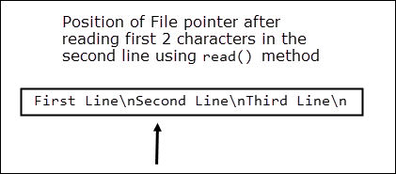
In line 10, the readline() is called again but this time it starts reading from the character c to the end of the line (including the newline character).
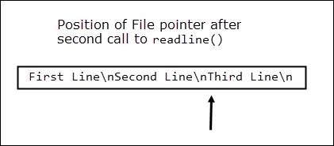
In line 13, readline() is called again, to read the last line. At this point, file position pointer is at the end of the file. That's why readline() call in line 16 returns an empty string ("").
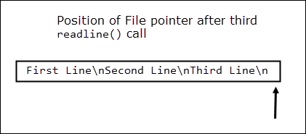
Example 4: Using readlines() to read data from a file.
python101/Chapter-18/readlines_method_demo.py
1  2  3  4  5  6 | f = open("readme.md", "r")  # read all the line as return and them as a list of strings  print(f.readlines())  f.close()
Output:
['First Line\n', 'Second Line\n', 'Third Line\n']

